Introduction to Agriculture
Agriculture is the practice of cultivating plants and livestock in order to provide facilities the human beings. In the rise of the sedentary human lifestyle agriculture was the key development. The cultivation of plant and food grains began years ago in order to provide food to the city population. Agriculture is the main need for the people to live in the society. Agriculture is the main source of livelihood, it provides a source for the people to earn. Most of the population in the rural areas is dependent on agriculture as their main source of income.
Agriculture contributes significantly to a country’s GDP that is the Gross Domestic Production of a country. By the passing of time, there are a number of revolutions that take place in order to improve agriculture throughout the world or a country. If we talk about agriculture, India has witnessed a number of revolutions, that is, the green revolution, yellow revolution, blue revolution, agriculture. Agriculture affects the biodiversity of a country depending upon agricultural activities.
The major agricultural products can be widely grouped into categories of food grains, fibers and raw materials.
Foodgrains included the grains or cereals that have been used for eating. Fiber crops are completely Commercial, they can not be eaten and are completely grown for making money. Raw materials are that category of crops that are completely grown for use as raw materials in industries in order to prepare other items.
This article provided to help you to learn the topic of agriculture about the history of farming, Commercial farming, primitive farming, its characteristics, types of Commercial Farming, intensive subsidence character, and so on. This will help you to get a clear view of agriculture. Let's have a look at it.

Problems definition & Design Thinking:
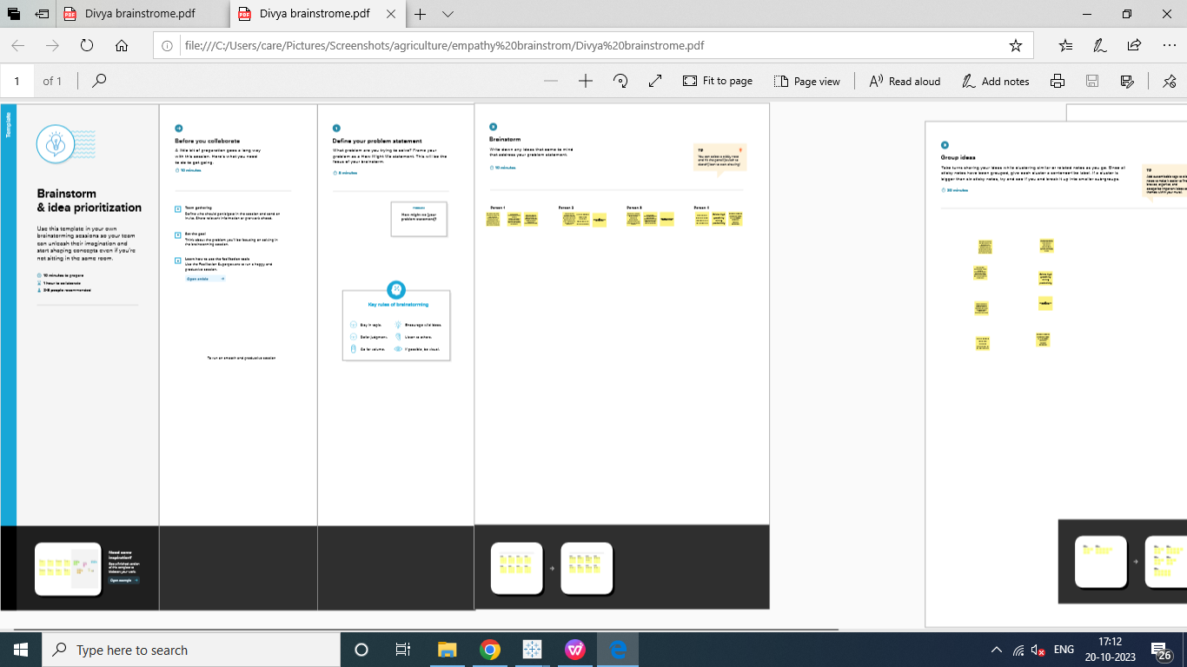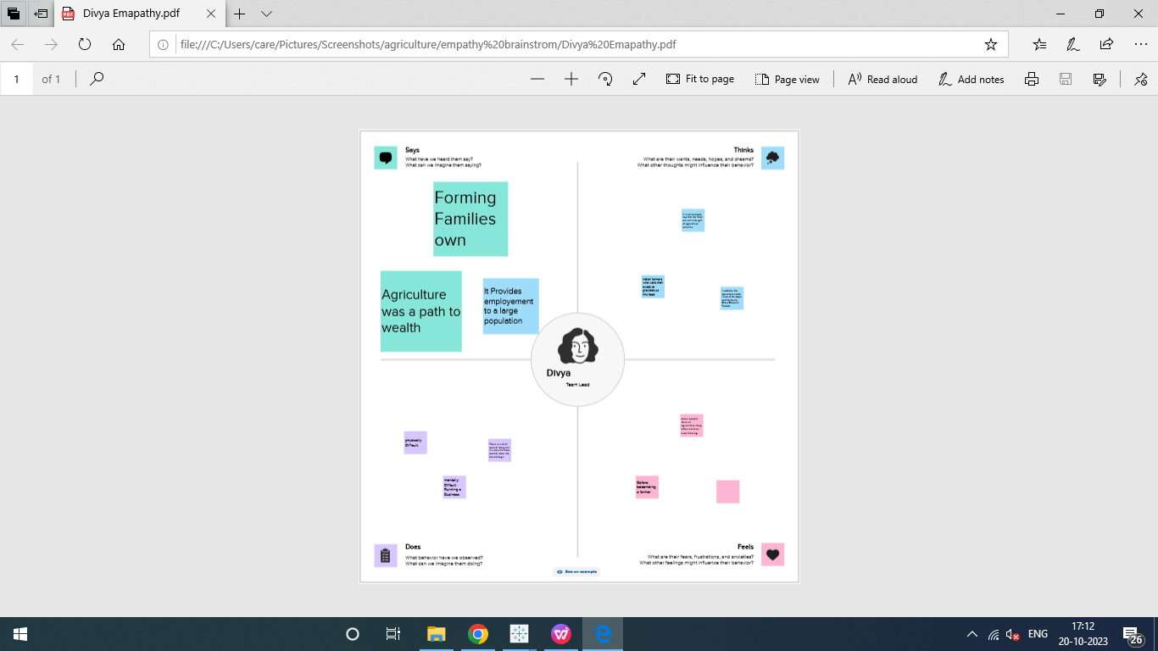

Result
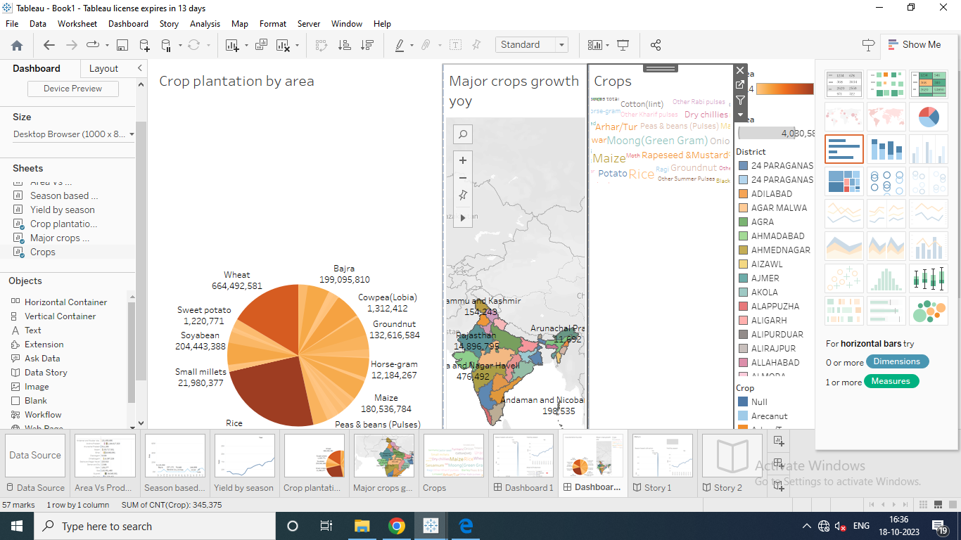

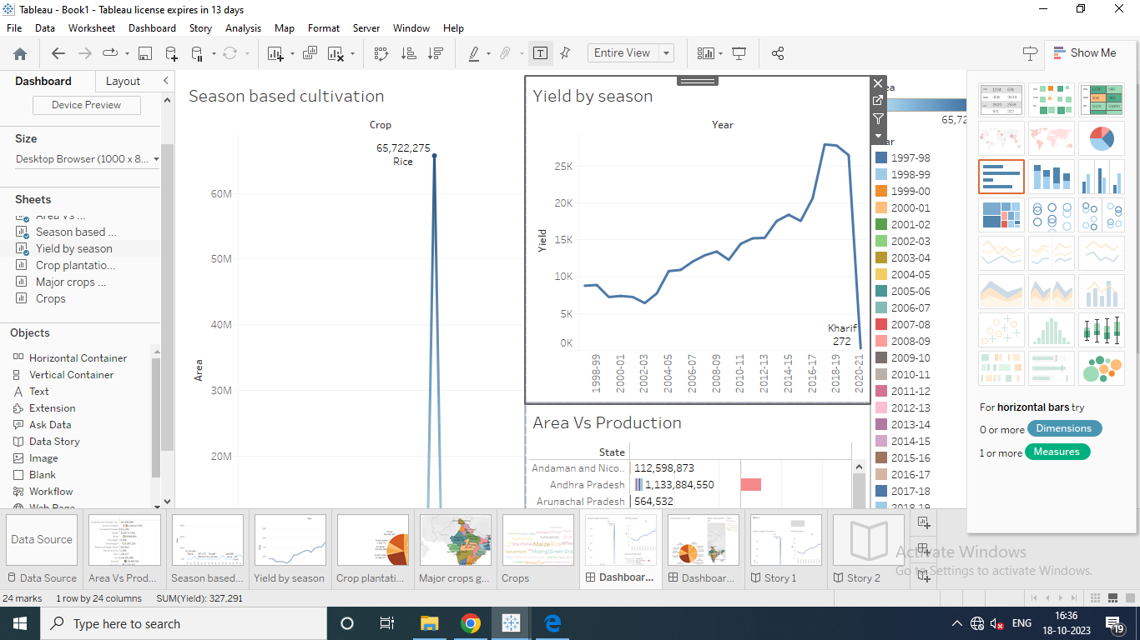
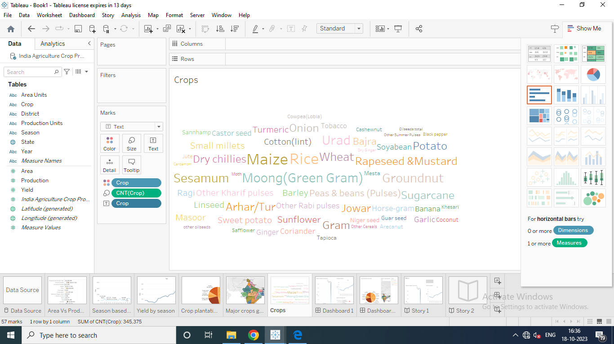

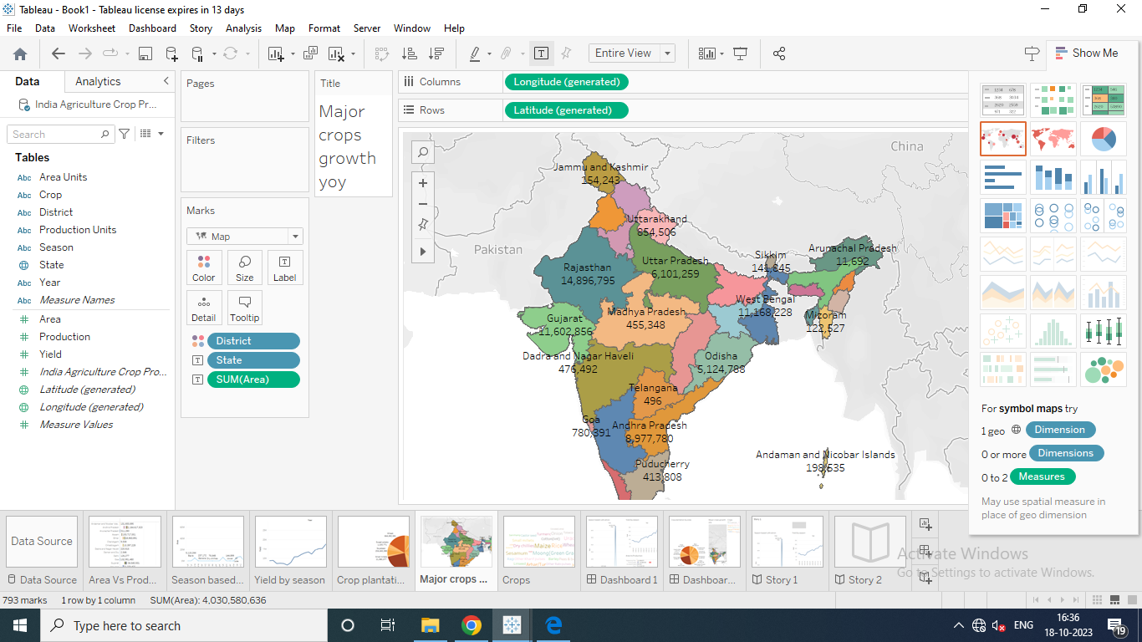
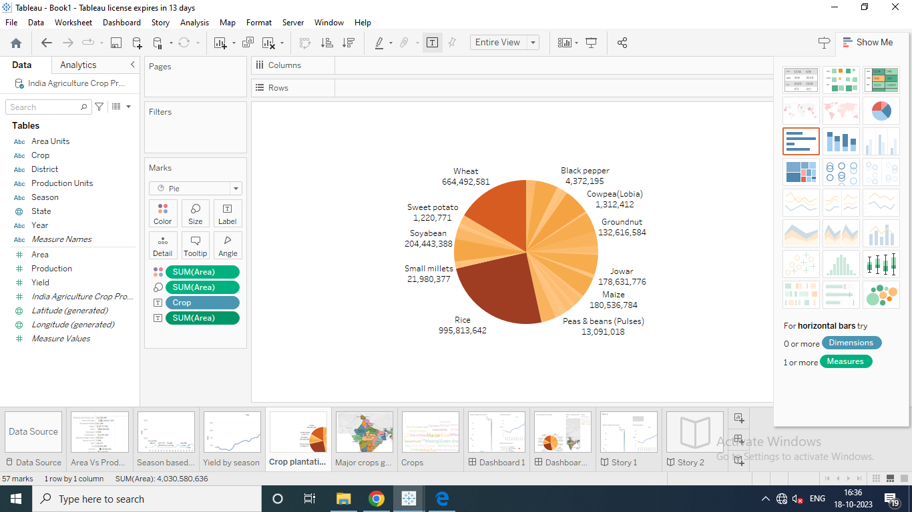

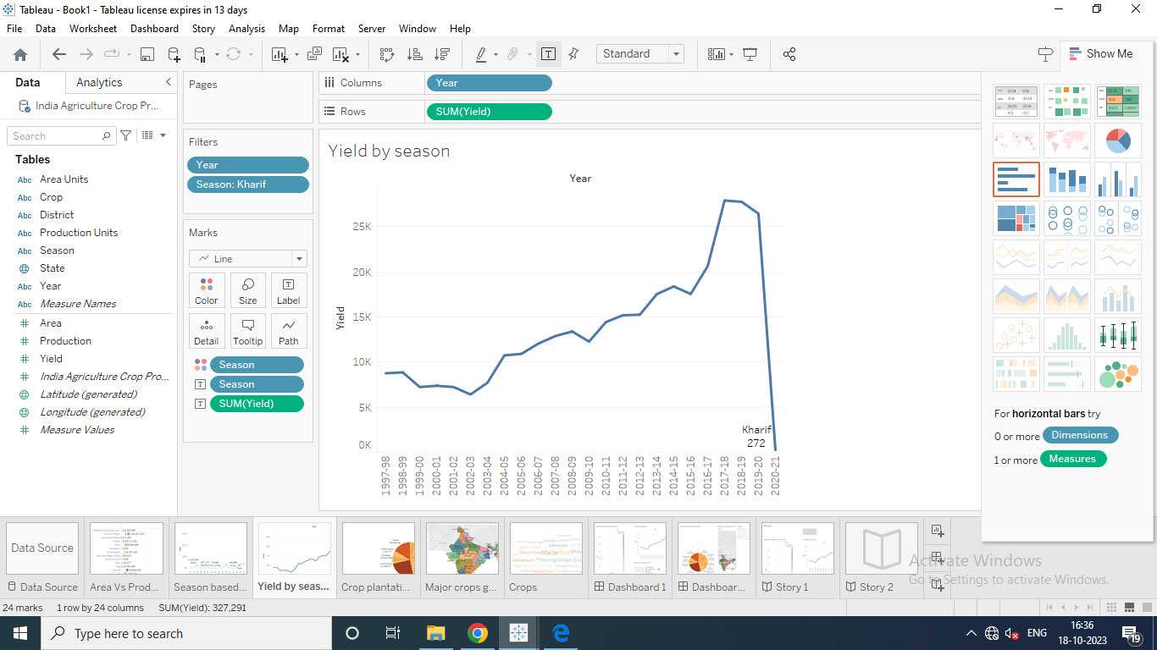
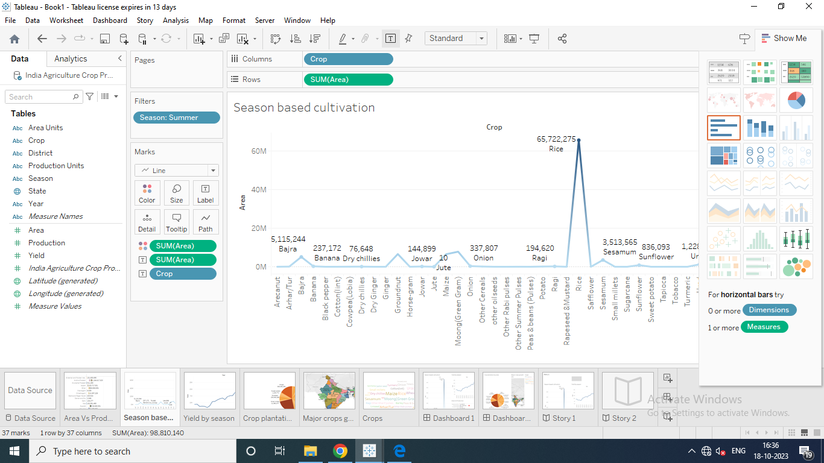

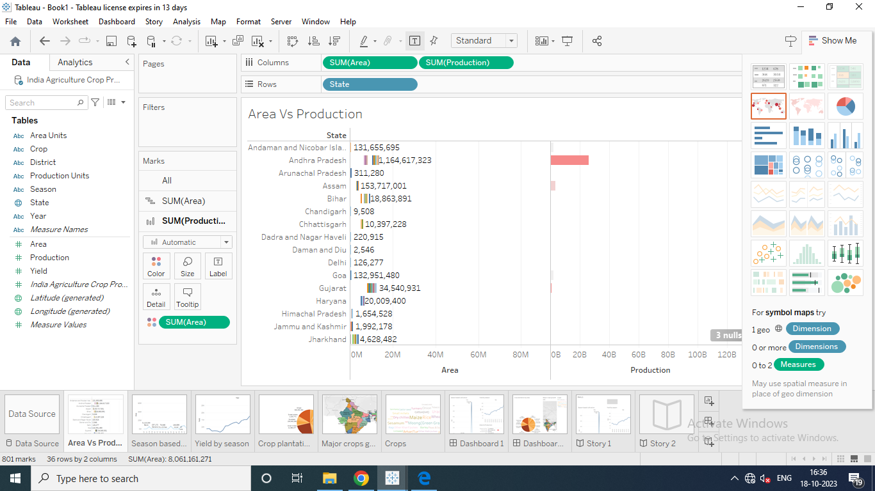
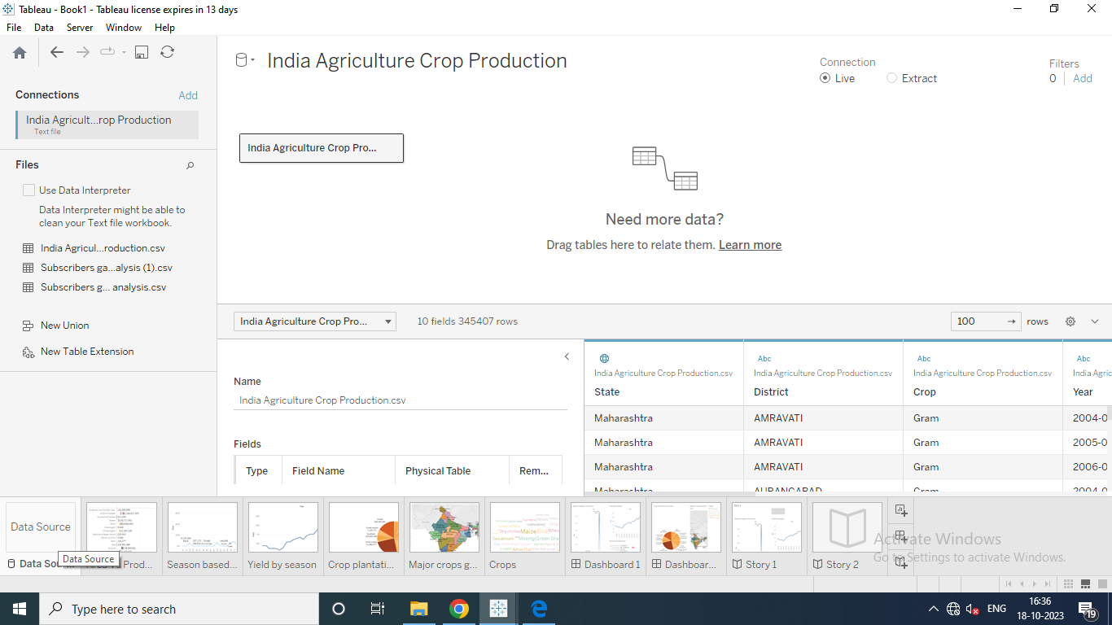

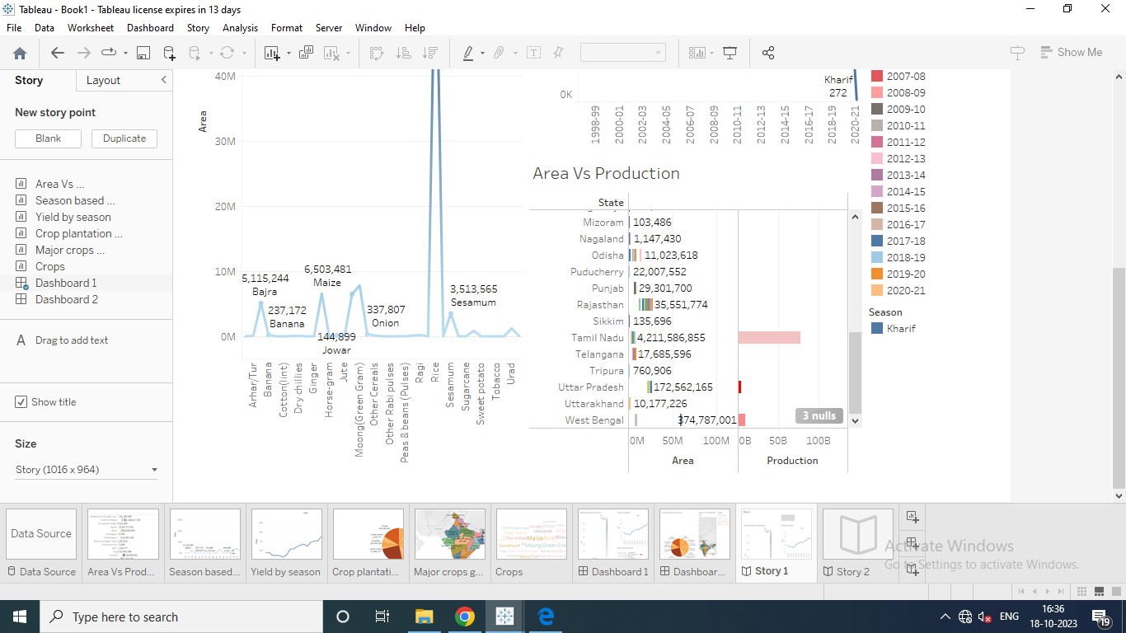

Advantages and Disadvantages:

Advantage: Controllable food supply. You might have droughts or floods, but if you’re growing the crops and breeding them to be hardier, you have a better chance of not starving.
Disadvantage: In order to keep feeding people as the population grows you have to radically change the environment of the planet.

Advantage: Especially if you grow grain, you can create a food surplus, which makes cities possible and also the specialization of labour. Like, in the days before agriculture, everybody’s job was foraging, and it took about a thousand calories of work to create a thousand calories of food, and it was impossible to create large population centres.
But, if you have a surplus, agriculture can support people not directly involved in the production of food. Like, for instance, tradespeople, who can devote their lives to better farming equipment, which in turn makes it easier to produce more food more efficiently, which in time makes it possible for a corporation to turn a profit on this ninety-nine cent double cheeseburger.
Some would say that large and complex agricultural communities that can support cities and eventually inexpensive meat sandwiches are not necessarily beneficial to the planet or even to its human inhabitants.
Advantage: Agriculture can be practised all over the world, although in some cases it takes extensive manipulation of the environment, irrigation, controlled flooding, terracing, that kind of thing.
Disadvantage: Farming is hard. So hard, in fact, that one is tempted to claim ownership over other humans and then have them till the land on your behalf, which is the kind of non-ideal social order that tends to be associated with agricultural communities.’

Application:
Agriculture is the backbone of India's economy. It is the principal livelihood for over 58% of the rural households. But it faces difficult challenges from sowing to harvest. Hence modernisation of agriculture is most needed to address these challenges. In agriculture there is a quick adaptation to AI in its various farming techniques where Artificial Intelligence (AI) is one of the key areas of research in computer science with its rapid technological advancement and vast area of application, AI is becoming relevant very rapidly because of its robust applicability in the problems particularly that cannot be solved well by humans. Such an area of extreme importance is agriculture where about 80% of the population is directly engaged on 159.7 million hectares of agricultural land. Such a venture cannot run smoothly. Hence farming solutions which are AI powered enable a farmer to do more with less, enhancing the quality, also providing a quick GTM (go-to-market strategy) strategy for crops.
A direct application of AI (Artificial Intelligence) or machine intelligence across the farming sector could act to be an apotheosis of shifting of traditional farming practice today. AI powered agriculture, analysing its service in interpreting, acquiring and reacting to different situation to enhance efficiency.Artificial intelligence technology is supporting different sectors in agriculture to boost productivity and efficiency. AI solutions are assisting to overcome the traditional challenges in every field. Intervening of AI in agriculture is helping farmers to improve their farming efficiency and reduce environmental hostile impacts. The agriculture industry strongly and openly grasped AI into their practice to change the overall outcome. AI is shifting the way of food production where the agricultural sector's emissions have decreased by 20%. Inculcating AI technology in agriculture is helping to control and manage any uninvited natural condition.

Conclusion:

India's agricultural sector is still very important to the Indian economy, although its share of the economy has decreased over the past 50 years. India has made significant advances in agricultural production in recent decades, including the introduction of high-yield seed varieties, increased use of fertilisers and improved water management systems. Reforms to land distribution, water management and food distribution systems will further enhance productivity and help India meet its growing demand for food.

Future Scope:
Agriculture is good for the future as it is expected to use advanced technologies and innovations to produce more food with limited land and resources, increase efficiency on farms, and become more profitable, efficient, safe, and environment friendly.
Appentix:
The 2008 American Samoa Census of Agriculture was conducted by personal interviews of all farm operations on the list of commercial farms, and supplemented by an area sample of the remaining households. The purpose of the area sample was to efficiently accountfor farms not on the commercialfarmlist and provide an accurate measure of the agricultural activity in American Samoa. SAMPLE DESIGN The design of the sample for the 2008 Census of Agriculture made use of materials and information available from the American Samoa Department of Commerce. These included detailed maps of all the islands in the territory, up-to-date map-spotting (location on a map) of all households in the territory, a system of numbering each household to provide it a unique identifier, and identification of householdswhich were on the list of commercial farms. The households that were on the list of commercial farms were excluded from the universe used to select the area sample. A random sample of the remaining households was selected, using the available maps with the household identification information. It was determined that a 20 percent sample would be optimal. A serpentine selection methodology, starting at a point determined by the generation of a random number, was used to select the area sample. DATA COLLECTION As in the previous agriculture census in American Samoa, enumeration was based on a list of farm operators compiled bythe American Samoa Department of Agriculture along with a sample of all households not on the list. All of the operators on the list were enumerated with certainty, and a random sample of the remaining households was selected to represent all operations not on the list. The data from these households were given a weight equal to the inverse of their probability of selection to the sample.
The statistics in this report were collected from farm operators during the period from late April to early July 2009. The enumerators were hired for the data collection phase of the census by the American Samoa Department ofCommerce. Enumerators were divided into teams, with each team responsible for a given area. The enumerators were required to contact all households identified on census maps in their assigned area and complete a census report form for all farm operations. If a person on the list of farm operators was not operating a farm, the enumerator was to record whether the land had been sold or rented to someone else and was still being used for agriculture. If so, the enumerator got the name of that person, and followed up to ensure that the operation was included in the census. The project manager, crew leaders, and enumerators employed for the census in American Samoa received special training in accordance with instructions prepared byNASS and the Department of Commerce of American Samoa. The training included practice in interviewing and filling out the report form plus detailed discussion of the enumerator's instructions. 2008 CENSUS OF AGRICULTURE A

